Time series Tools

Purpose
This module offers a set of functions on time series. These functions are:
- Harmonic analysis; this allows the user to calculate harmonics for time series up to a maximum harmonic
- Harmonic composition; this is the reverse of harmonic analysis. Calculate the reconstructed time series.
- Timed aggregation; aggregate values in the time series to a different (larger) time interval
- Timed interpolation; use linear interpolation on the values, decreasing the time interval
- Correlate with profile; correlate each location with a user specified time profile
- Sensitivity analysis for the correlation with profile function

Installation
Install the .sav files in the save_add folder (see also ENVI .sav files: Installation and configuration.
_nrsmenu.sav Define NRS menu item in ENVI
nrs_Utils.sav Library with utility routines
nrs_timeseries.sav The actual software

Usage (gui)
nrs_harmonic_gui | Start the user interface of the harmonic analysis.
nrs_harmonic_inv_gui | Start the user interface of the harmonic composition.
nrs_correlate_profile_gui | Start the user interface of the correlation with profile
nrs_correlate_avg_profile_gui | Start the user interface of the sensitivity analysis for the profile correlation
Alternatively the commands can be started from the ENVI menu: ‘NRS | Timeseries’:
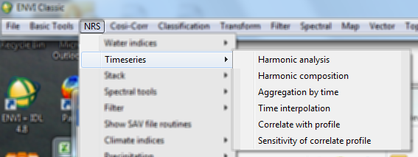

Harmonic Analysis
Menu option is ‘NRS | Timeseries | Harmonic analysis, the command line is ‘nrs_harmonic_gui’. This function calculates the harmonic decomposition of a time series using FFT. The decomposition is done in slices of one year and generates one decomposition per year.
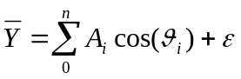 (1)
The user interface is shown below:
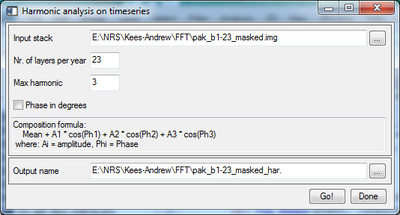
Explanation of all the fields:
Input stack | Select an input stack (time series)
Nr. of layers per year | Specify the number of layers per year
Max. harmonic | Specify the maximum number of harmonics to calculate. The algorithm requires this to be lower than half the number of layers per year for correct results.
Composition formula | Documents the basic formula for the chosen number of harmonics. Note that the coefficients are the output bands.
Output name | The filename of the output harmonic coefficients.

Correlate with profile
Menu option is ‘NRS | Timeseries | Correlate with profile, the command line is ‘nrs_correlate_profile_gui’. This function calculates the linear Pearson correlation coefficient. The correlation uses the same profile for each location in the time series.
The user interface is shown below:
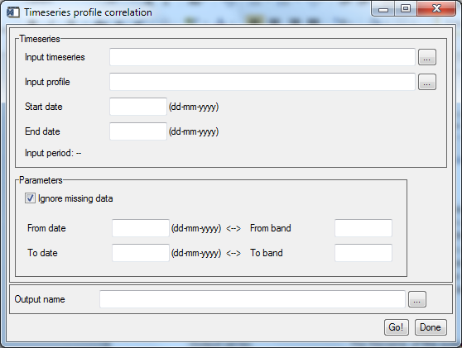
Explanation of all the fields:
Input timeseries | Select an input time series
Input profile | Select the table with the profile data. Expected are two columns, the first with the date and the second with the profile values. The table should be in CSV file format.
Start date | Specify the start date, that is, the date associated with the first band in the time series.
End date | Specify the end date, that is, the date associated with the last band in the time series.
Input period | The software reports the time interval when the time series, the start date and the end date are specified
Ignore missing data | If switched on the software will only correlate the actually available data, skipping the missing data
From date | [Optional] Specify from which date the correlation should be calculated
To date | [Optional] Specify to which date the correlation should be calculated
From band | [Optional] Specify from which band the correlation should be calculated
To band | [Optional] Specify to which band the correlation should be calculated
Output name | The filename of the output correlation values.
Note: The from date and from band fields and the to date and to band fields are synchronized: if a date is specified the associated band is calculated, and vice versa if a band is specified the associated date is calculated. The date calculation from band number always points to the start of the period indicated by the band.

Sensitivity analysis for Correlate with profile
Menu option is ‘NRS | Timeseries | Sensitivity of correlate profile, the command line is ‘nrs_correlate_avg_profile_gui’. This function iteratively samples the input dataset using a random spatial selection. This temporal profile of this selection is averaged and correlated with a reference profile (linear Pearson correlation). Both the number of iterations and the sample percentage are use specified.
The user interface is shown below:
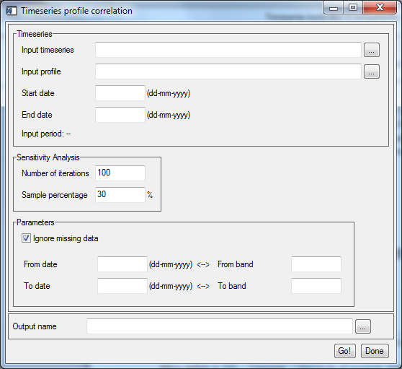
Explanation of all the fields:
Input timeseries | Select an input time series
Input profile | Select the table with the profile data. Expected are two columns, the first with the date and the second with the profile values. The table should be in CSV file format.
Start date | Specify the start date, that is, the date associated with the first band in the time series.
End date | Specify the end date, that is, the date associated with the last band in the time series.
Input period | The software reports the time interval when the time series, the start date and the end date are specified
Ignore missing data | If switched on the software will only correlate the actually available data, skipping the missing data
Number of iterations | The user specified number of iterations
Sample percentage | The percentage of the spatial area to select for the temporal correlation
From date | [Optional] Specify from which date the correlation should be calculated
To date | [Optional] Specify to which date the correlation should be calculated
From band | [Optional] Specify from which band the correlation should be calculated
To band | [Optional] Specify to which band the correlation should be calculated
Output name | The filename of the output correlation.
Note: The from date and from band fields and the to date and to band fields are synchronized: if a date is specified the associated band is calculated, and vice versa if a band is specified the associated date is calculated. The date calculation from band number always points to the start of the period indicated by the band.
Note: The spatial locations are sampled randomly with a uniform distribution. At each iteration an independent random selection is generated.
The output is a text table (CSV formatted) with two columns, one for the iteration number and one for the calculated correlation for that iteration. A small sample:
iteration, correlation
1,0.79936729
2,0.78976907
3,0.81668644
…

References

